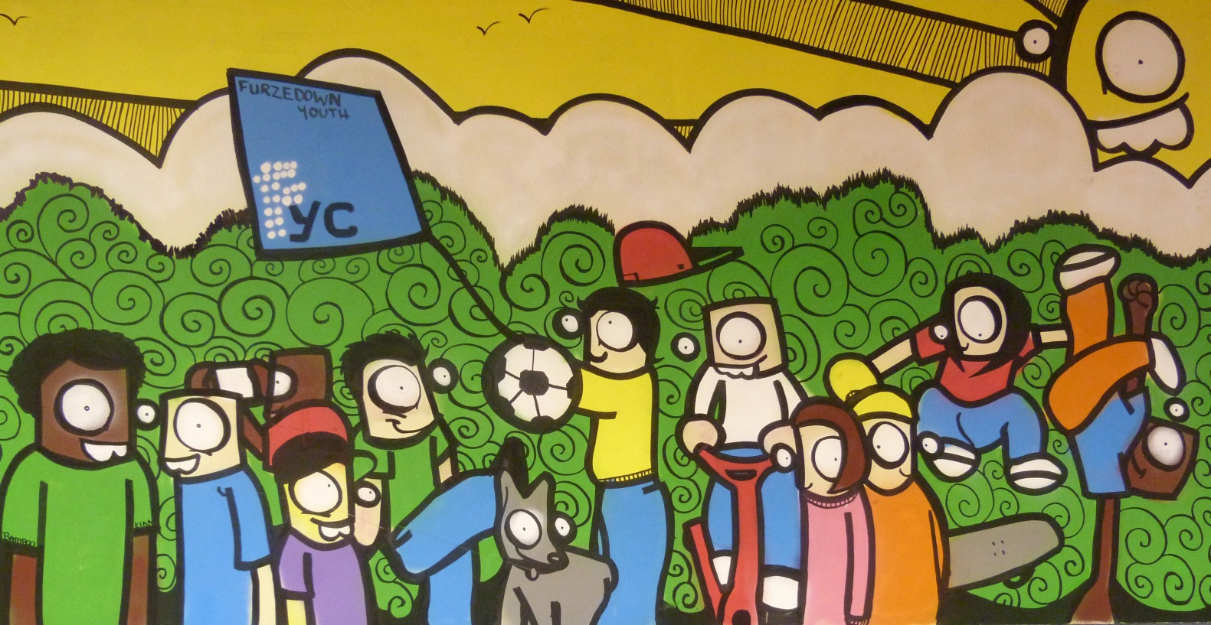
Furzedown Youth Centre
236 Mitcham Lane, Streatham, London, SW16 6NT
Registered Charity No. 1111797
www.furzedownyouthcentre.org.uk
Your Guide to Volunteering at Furzedown Youth Centre
Welcome to the team!
For as long as Furzedown Youth Centre (FYC) has been running volunteers have been integral to the work that we do. FYC was set up by a group of committed local volunteers and when sessions started the majority of the youth work team were volunteers who were looking to help young people in Furzedown. Today our Board of Directors give their time and skills free of charge to govern FYC whilst others come from Merton, Lambeth and Wandsworth to run activities, serve on our bar, play sports and support the young people who come through our doors. Volunteers have been, are currently and will continue to be a vital part in our work with young people.

We love working with volunteers because they have a real passion for making a difference and each individual brings something different that benefits both our young people and the team. It’s our volunteers, along with the young people, who are the best ambassadors for the work FYC does as they cannot help but tell others what they are part of at FYC. Our volunteers find being at FYC infectious and we will work hard to make sure you feel the same during your time with us.

We hope this booklet will provide you with an introduction to some of the key things you need to know about FYC. If you need any more information then please do contact the person named below.

Thanks for your interest in FYC and we hope that your time volunteering with us will be eye-opening, inspiring and life-changing!

Your supervisor/named contact person is:

Name ………………………………………………………………………………………….
Phone number ………………………………………………………………………………
Email address ………………………………………………………………………………

You can contact the above person about anything related to FYC and if they cannot help you they will do their best to find you someone who can.

What is Furzedown Youth Centre?
FYC was established in 2003 by local people who saw that there was nowhere for young people in Furzedown to meet safely with their friends. It was set up and supported by four local churches: St James, St Alban’s, St Paul’s (all Church of England) and Mitcham Lane Baptist and welcomes all young people regardless of race, gender, culture, sexuality or religion.

FYC is a safe and secure place where young people can develop socially, emotionally, physically and spiritually. We provide fun activities that aim to challenge and encourage young people and we always make sure there is time to talk with young people, listening to what’s happening in their lives and support them in whatever way we can. Over the years a number of young people who have attended FYC sessions have joined our volunteer team and have begun putting into practice what they have learnt by helping others.

Currently there are two main sessions Juniors and Inters. These are centre-based youth club sessions for local young people between the ages of 10 and 16. Juniors focuses on school years 6&7 and Inters is school year 8-11. There are volunteer roles available within both sessions. If you are unsure about what would suit you best please do speak to one of FYC’s staff members.
“It’s just mad in here, everyone feels happy and able to be themselves. Everyone gets hyped up and you feel like you want to stay all day.”
R (Young Person & Volunteer)
“A really fun safe imaginative place for children to be children”
Emma (Parent)

“The only place of its kind in the area…providing opportunities for our children, exciting activities and a friendly place to hang out.”
Tom (Parent)

“It’s different from the other places I’ve been. There is staff in every room who you can talk to about anything without them judging you. It’s special.”
H (Young Person)

Volunteering – The Essentials
At FYC we believe that it takes a whole community to help and support a young person and it’s therefore important for us to have a diverse team of volunteers who come from a variety of areas, ages, backgrounds and experiences. There are volunteers on our team who had never seen or done any youth work before coming to FYC, and there are others who have worked with young people for many years. No matter what your level of experience, you have something to offer.
We asked our team what they thought all FYC volunteers had in common and they said;
- communication skills (talking and listening)
- team work skills
- respect
- an ability to try new things
- commitment
- compassion
However they also said that an FYC volunteer should be willing to persevere so please don’t be put off if you feel you are not strong in all of the above areas; we can work with you to develop your skills.
Here’s what one of our recent volunteer said about their experience at FYC:
“I started off thinking that I could do something in my area, that it would be fun and something to do. I didn’t realise how much the young people would look up to me and recognise me from living round here. I have learnt a lot about being a role model and how I have to act like one at FYC and outside as well. I feel more confident, and more hopeful.”

What will FYC do for you whilst you are volunteering?
Being a volunteer at FYC is an important role and we want to make sure you are supported during your time with us which is why we will:
- Meet with you to discuss what skills and experiences you feel you have in order to determine how these can be used best at FYC
- Provide you with a clear description of your voluntary role at FYC and
the responsibilities you will have
- Look after any personal information that we require from you, letting you know why we need it, storing it safely so no one can access it and not giving it to others without asking you first
- Provide you with an induction to FYC and initial training to make sure you feel settled and able to carry out your responsibilities
- Make sure you are assigned a supervisor who can provide you with regular supervision, advice and support as well as feedback on your progress and future targets to aim for
- Provide you with on-going opportunities to learn and develop within your voluntary role, this may include training at FYC and relevant courses run by other organisations
- Ensure you have a copy of all policies relevant to your volunteering role
- Explain the expenses procedure to you and ensure that you are reimbursed when appropriate
- Provide you with a reference from your supervisor when appropriate
What will you need to do for FYC whilst you are volunteering?
During your volunteering you will be either working directly with young people, or in a space which young people use. So in order to keep everyone safe we ask that you:
- Be respectful of all religious views and understand that FYC is based on Christian values
- Provide FYC with at least one reference when requested
- Complete a Disclosure and Barring Services check (if you are 16 years and above) when requested in the knowledge that the information given will only be seen by authorised professionals
- Participate in induction sessions and other core training that you may be required to attend
- Accept and work in line with FYC’s policies and procedures, particularly in relation to confidentiality, accident reporting, health and safety, equal opportunities and criminal record and reference checks
- Do your best to be on time for youth work sessions and training
- Let your supervisor know if you are unable to attend a session with as much notice as possible
- Give as much notice as possible that you are unable to continue volunteering (we will want to say a proper goodbye to you!)
- Talk to your supervisor if there is something you are unhappy with at FYC so that we can work on the issue together
- Look after yourself, your team members and the young people at FYC by not putting you or them in unnecessary danger
- Make sure your social media profiles (Facebook, Twitter etc.) are set to private so young people cannot access your profile. We ask that you do not add or accept young people’s friend requests; it’s important that you maintain good boundaries whilst volunteering and treat the young people as people who you work with rather than friends. Please talk to your supervisor about this if you want to know more.

Starting and Ending Your Volunteering at FYC

We want to make sure that volunteering with us is something that you enjoy and benefit from which is why we do a number of things before you start your role. These include:
- Inviting you for an informal interview so we can get to know you, you can ask us questions and find out more about the opportunities available
- Asking you to provide at least one reference from a previous employer, work experience placement or similar so that we get a feel for what responsibilities you have had in the past
- Inviting you for an intro session at FYC where you can observe how things run, meet the team and shadow a worker
- Helping you fill out a Disclosure and Barring Service Check so we can verify your details and ensure you are right for the volunteering roles available at FYC. (Having a criminal record will not necessarily prevent someone from volunteering at FYC, but may impact the programmes with which they are able to volunteer on.)
- Agreeing on an introductory period (usually two months) during which time you and your supervisor will have more time to think about whether you are in the right volunteering role. At the end of the period you will meet and discuss how long you would like to continue volunteering for and if necessary what targets you would like to set yourself.

At FYC we understand that for some people volunteering is a short term activity, and even those who commit for long periods of time with eventually leave. Please do let us know if you are thinking of ending your volunteering with us so we can talk to you about it, prepare the young people for your departure and say a proper goodbye and thank you. If you have volunteered with us for three months or more we can provide you with a reference so please speak to your supervisor about this.

Comments and Complaints at FYC
FYC has grown and gained an excellent reputation partially due to our commitment to listening to young people, their parents, our volunteers and the community we serve. We therefore welcome all comments that help us shape our service and you should always feel that you can talk to your supervisor or any of the FYC staff.
If you have a complaint, please discuss the issue with your named supervisor. If the complaint is about your named supervisor or if you feel your complaint is not dealt with to your satisfaction in a reasonable amount of time, then follow the procedure below.

- Your complaint should be made in writing, marked “Private & Confidential", and sent to the named person below. This person will be a director on the Board or the President of FYC. They will acknowledge it in writing within 7 days of receipt. Remember to keep a copy of your letter. If you need an interpreter or advocate to help you, FYC can arrange this for you.
- The named person will investigate the complaint with another Member of the Board.
- The named person will communicate the results of the investigation to you within a reasonable time, and no more than 21 days.
- If you are dissatisfied with the results of the inquiry, you may put your case in writing or personally to a panel comprising at least three members from the Board of FYC. If attending personally, you have the right to be accompanied by a friend or advocate to help put your case. The panel also has the right to have an advisor present.
- The decision of the panel will be final.
- Where appropriate, FYC will make a written apology to the complainant, and agree any further action necessary to make good the cause of the complaint.
- All formal complaints and the response made to them will be recorded and filed in a secure place.
- The Board of Directors shall be informed by the named person below at the first available meeting of the number and nature of any formal complaints and their outcome, and consideration will be given to the implications these have for the planning and management of future services.

Formal Complaint must be sent to (to be confirmed):
Name: ________________________________________________________
Position: _______________________________________________________
Mailing Address: Furzedown Youth Centre, 236 Mitcham Lane, London, SW16 2SR
Email address: _________________________________________________
The practical bits: procedures and info you’ll need throughout your volunteering at FYC
(please refer to FYC Policy booklets for more)
Safeguarding Young People at FYC

We want to make sure the young people who attend our sessions are not in any danger and we therefore ask you to be aware of the following forms of abuse and ways they may be displayed.

Physical Abuse  Risk or actual physical injury or failure to prevent injury/suffering to a young person  Symptoms:  Bruises  Broken bones  Cuts and grazes  Behaviour changes / wet bed / withdrawal / regression  Frequent unexplained injuries  Finger marks  Cigarette burns  Fear of physical contact  Violent behaviour during role play  Unwillingness to change clothes  Aggressive language and use of threats  Cowering  Bruising in unusual areas  Changing explanations of injuries  Not wanting to go home with parent or carer | Sexual Abuse  Risk or actual sexual abuse  Symptoms:  Inappropriate behaviour – language  Withdrawn  Change of behaviour  Sexual explicate behaviour  Rejecting physical contact or demanding attention  Physical evidence – marks, bruising  Pain going to the toilet, strong urine  Rocking  Relationships with other adults or children for example, being forward  Non-age appropriate knowledge  Stained underwear  Bruising / marks in genital area  Drawing – inappropriate knowledge  Inappropriate physical contact  Secretive online behaviour  Disclosure
Neglect Abuse  Failing to protect a young person from exposure to any kind of danger including cold or starvation  Symptoms:  Dirty  Lack of appropriate clothing  Cold – complaining of  Hunger – complaining of  Body sores  Urine smells  Unkempt hair  No parental interest  Not wanting to communicate  Behaviour problems  Attention seeking  Lack of respect  Often in trouble – police  Bullying  Use of bad language  Always out at all hours  Stealing  Lack of confidence – low self esteem  Jealousy | Emotional Abuse  Actual or risk of effect on emotional and behavioural development of young person by severe emotional ill-treatment or rejection.  Symptoms:  Crying  Rocking  Withdrawn  Not wanting to socialise  Cringing  Disclosure  Bad behaviour  Aggression  Behaviour changes  Bribery by adult to attend school  Self mutilation  Lack of confidence  Attention seeking  Isolation from peers (unable to communicate/ unable to socialise)  Clingy  Afraid of authoritative figures  Treating others as you have been treated
If you see a young person or another volunteer displaying any of the above behaviour and you’re concerned please speak to the youth worker in charge and/or FYC’s safeguarding officer (up to date contact details are in FYC).
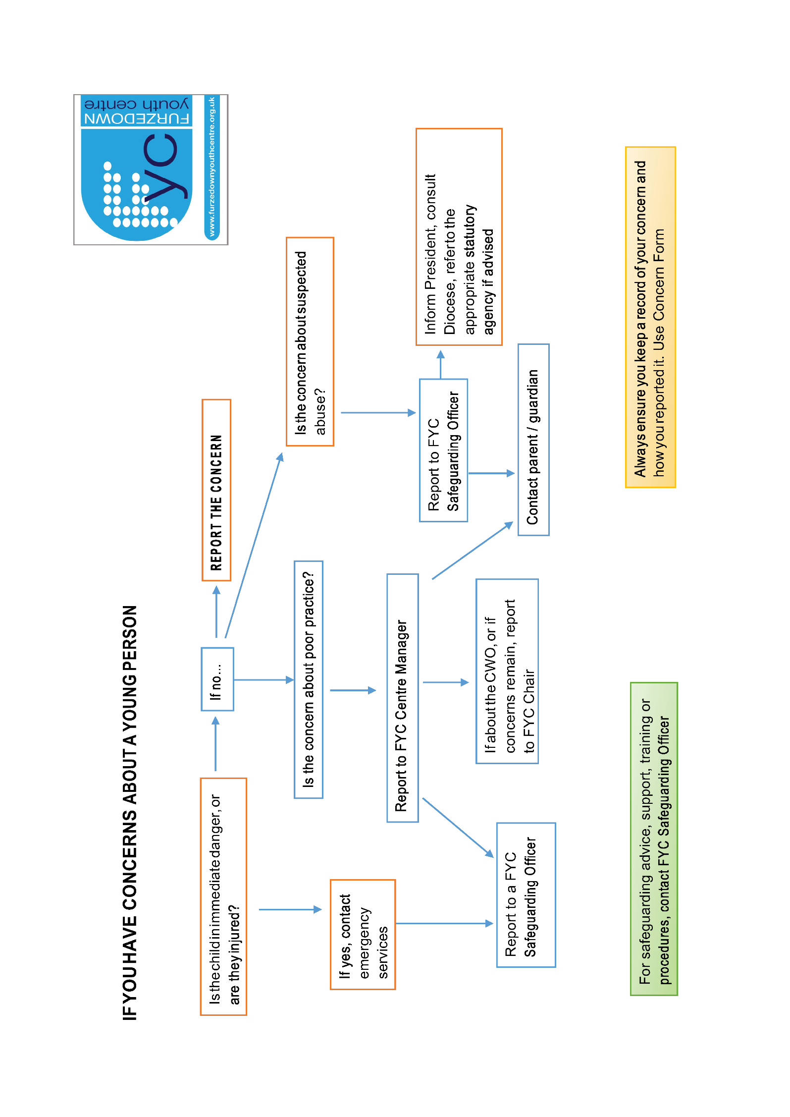
Reporting Safeguarding Concerns (the flowchart below to be displayed in FYC)
Example of FYC’s Cause for Concern Form

Safeguarding children and young people cause for concern form

Strictly private and confidential
(Completed forms must never be forwarded electronically via email systems)

Please complete this form in as much detail as possible using the young person’s consent form to obtain address, contact details etc. if information is not known to you.

Name of young person:
Gender: (M/F) Date of birth: Ethnicity:
Address:

Contact telephone number(s):
School:
GP:
Name of main carer (specify relationship):
Address and phone number:

Does the main carer know the referral is being made?
Does the young person know the referral is being made?
Which Furzedown Youth Centre session does the young person attend?

Name of person filling in this form:

Address:

Brief description of what has given you cause for concern. Include date(s), time(s) and event(s):

If not already clear in the information given above please state who you have spoken to about this matter and what was said:

Please state what action you have taken (especially any emergency action such as phone calls to FYC’s Safeguarding Officer):

Signed: Date:
Print name:
Position held at FYC:
Now put this report in a sealed envelope marked ‘To FYC’s Safeguarding Officer, PRIVATE & CONFIDENTIAL’ & hand it to the youth worker in charge of the session.
Health & Safety at FYC

In order to keep yourselves and the young people at FYC safe we ask you to work as a team to look after one another.
First Aid should only be carried out by the nominated first aiders but you should make sure you know where the first aid box is kept so you can retrieve it if necessary. Please speak to your supervisor if you feel first aid training is something you would like to do.
Accidents and incidents should be written down in the reporting book so there is a record of what happened. Make sure you know where this is kept at FYC.
Broken or faulty equipment should be disposed of appropriately as soon as possible. If you are unsure about this please check with a staff member.
Exits and fire escapes need to be kept clear at all times in case we need to get out of the building quickly. Please be aware of this when in the centre and encourage others to keep exits free of rubbish and furniture.
Look after yourself by thinking about how you lift things, using ladders etc and ask for help rather than putting yourself at risk.
Lost property should be handed to the youth worker in charge at the end of the session. Volunteers should encourage young people to look after their own possessions throughout sessions as FYC cannot be responsible for looking after them.
Fire evacuation procedure
Fire evacuation drills will be carried out at least once a term at all sessions. You should make sure you are familiar with escape routes (see next page) and if you do not please speak to your supervisor about this.

In the event of a fire:
1. Immediately raise the alarm
2. Escort young people off of the premises encouraging them to leave their possessions at the youth centre and walk calmly to the meeting point with them.
3. Support staff in taking the register and ensuring all young people are at the meeting point.
4. Telephone the emergency services or get another team member to
5. Only go back in the building once the fire brigade and the youth worker in charge have said it is safe to do so.

See next page for a map of fire evacuation procedure.
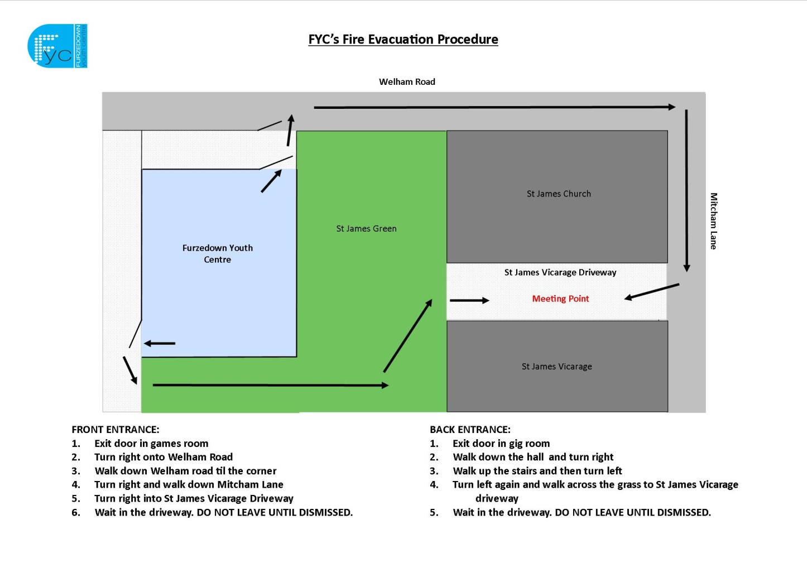
Internet & Computer Use at FYC

At some of our sessions young people are allowed to use the computers but may only do so once they have agreed to and signed the below agreement. It is designed to help them look after themselves and the computers; please make sure you know what it says so you can help the young people stick to it.

RESPONSIBLE INTERNET USE
Young Person’s Agreement

All young people using the Internet at Furzedown Youth Centre should sign two copies of this document as a record that they understand how to look after the computers and themselves.
Young people will keep one copy of the agreement and FYC will keep the other on file.
- I will respect the files saved on the computers by not changing them or claiming I created them.
- I will talk to a Youth Worker if there are any programmes that I want to download to see if it is possible.
- I will make sure a Youth Worker knows I am using the Internet.
- I will always be polite and respectful when sending messages.
- I will keep my personal information (my home address, telephone number, photos or other details) private and won’t share them on the Internet.
- I will keep others people’s personal information private and not share it on the Internet.
- I will keep myself safe by not arranging to meet anyone who contacts me through the Internet.
- I will report any e-mail messages which are unpleasant or which ask me to do something which might get me into trouble.
- I will report immediately any web page, messages or pictures which are illegal or offensive.
- I will be careful not to damage the computers and I will keep food and drink away from them.
- I understand that the FYC team want to keep me safe and may do this by checking my computer files and Internet history.
- I understand that a Youth Worker can ask me to stop using the Internet for an agreed period of time if they think I am not using the computers respectfully.
- For young people in Juniors club – I will not use Facebook on the FYC computers as I understand that I need to be age 14 and above to have a Facebook account

Signed ________________________________________ Date_______________________

FYC’s Respect Agreement

At FYC we encourage the young people we work with to be the best that they can be, in whatever way is appropriate for them. Often that means reminding them of what behaviour is acceptable at FYC and how they can help make the centre, and the wider community, a positive and fun place.
In late 2012, volunteers were concerned with how FYC’s young people were behaving towards one another. They decided to ask everybody how they would like to be treated whilst at FYC and out of the discussions our respect agreement was born.
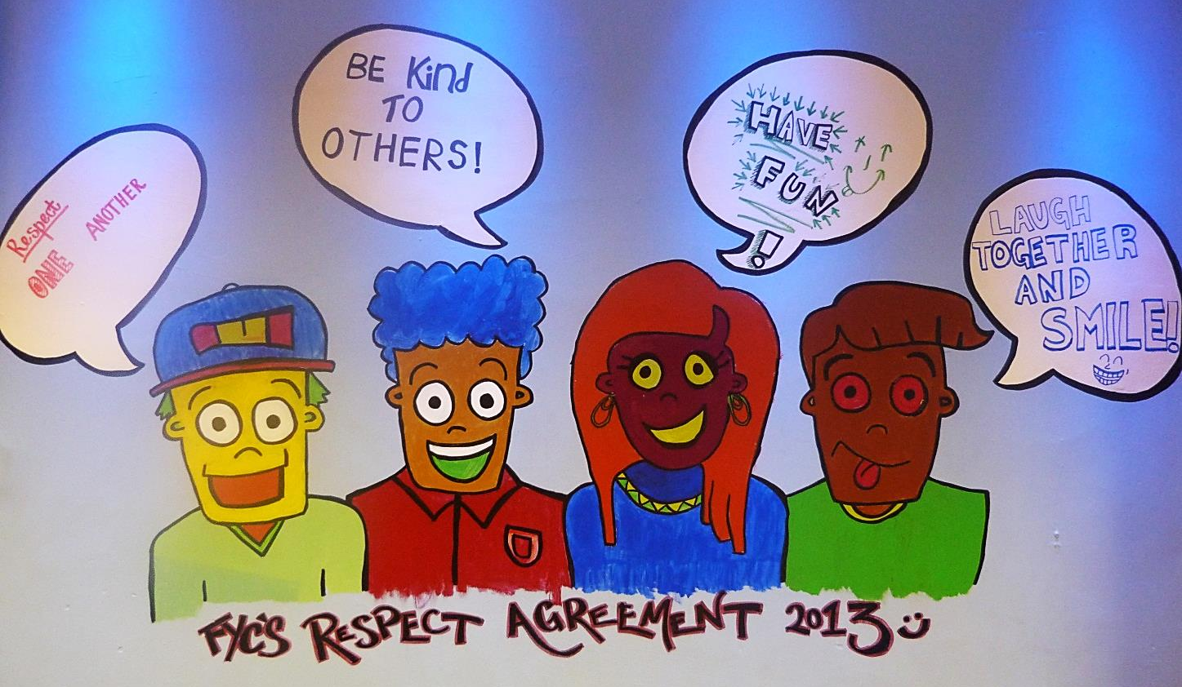
The respect agreement was designed as an alternative to having rules that young people have to follow. We believe that rules are often quite restrictive whereas our four key expectations (see above photo) are broad and can be applied to most positive and negative behaviour that may occur at FYC. For example, if we asked a person not to swear because it’s against the rules there is little room for conversation whereas with the agreement we can remind them that FYC is a safe place where we want people to have and give respect. This may then lead to a conversation about how the young person is in charge of their own actions and has potential to act more maturely than they have previously done.

Please discuss this with your supervisor if you want more information or a better understanding of how the agreement works at FYC.
